Norther Spy Kale Salad

2014 Thanksgiving (Eli, Anna, Jawas): came out really well. No fancy dressing necessary--just the lemon, olive oil suggested is perfect.
2015 Thanksgiving (Eli, Puneet, Pranav, Batras): will get already cubed squash

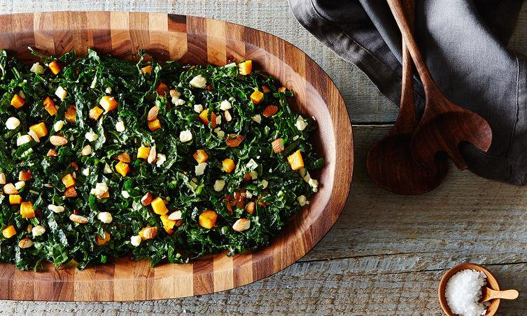

Author Notes: This salad is ideal for making ahead for company (or tomorrow's lunch) and has been a mainstay on the menu atNorthern Spy Food Co. in Manhattan's East (…more) - Genius Recipes
Serves 2
1/2
cup cubed kabocha, butternut, or other winter squash

Extra-virgin olive oil

Salt and freshly ground pepper
1
bunch kale (preferably lacinato or dinosaur kale), ribs removed and finely sliced, about 2 1/2 cups

1/4
cup almonds, cut roughly in half
1/4
cup crumbled or finely chopped Cabot clothbound cheddar (or any good, aged cheddar -- if you can't find aged cheddar, use parmesan)
Fresh lemon juice

Pecorino or other hard cheese, for shaving (optional)

- Heat oven to 425° F. Toss squash cubes in just enough olive oil to coat, and season with salt and pepper. Spread on a baking sheet (lined with parchment for easier cleanup), leaving space between the cubes. Roast in the oven until tender and caramelized, about 40 minutes, tossing with a spatula every 10-15 minutes. Toast the almonds on a baking sheet in the same oven until they start to smell nutty, tossing once, about 10 minutes. Let cool.
- In a large mixing bowl, toss the kale with the almonds, cheddar and squash. Season to taste with lemon juice and olive oil (approximately 1 tablespoon lemon juice and 2 tablespoons olive oil). Season to taste with salt and pepper.
- Divide salad between two plates or shallow bowls. Garnish with shaved pecorino cheese, if desired, and serve

